MOUNT VERNON PLACE

[-AA+A](javascript:;)

MOUNT VERNON PLACE

[-AA+A](javascript:;)

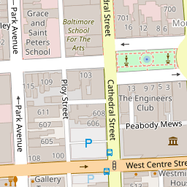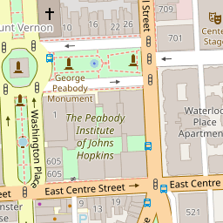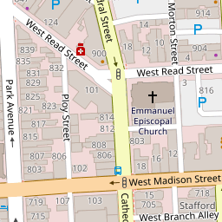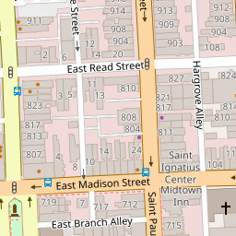





[**+−**](https://sah-archipedia.org/buildings/MD-01-510-0002)

[Leaflet](http://leafletjs.com/) | OSM Mapnik

FACTS

* LOCATION:

Baltimore Maryland

REGIONAL ESSAYS:

[Maryland](https://sah-archipedia.org/essays/MD-01)[Baltimore city](https://sah-archipedia.org/essays/MD-01-510)

ARCHITECT:

[Robert Mills](https://sah-archipedia.org/Architects/Robert-Mills)[Frederick Law Olmsted, Sr.](https://sah-archipedia.org/Architects/Frederick-Law-Olmsted-Sr)[Carrère and Hastings](https://sah-archipedia.org/Architects/Carr%C3%A8re-and-Hastings)

TYPES:

[squares (open spaces)](https://sah-archipedia.org/search/type/squares-open-spaces)[urban parks](https://sah-archipedia.org/search/type/urban-parks)[urban planning](https://sah-archipedia.org/search/type/urban-planning)[landscape gardens](https://sah-archipedia.org/search/type/landscape-gardens)[sculpture gardens](https://sah-archipedia.org/search/type/sculpture-gardens)

STYLES:

[Beaux-Arts (style)](https://sah-archipedia.org/search/style/Beaux-Arts-style)

MATERIALS:

[granite (rock)](https://sah-archipedia.org/search/material/granite-rock)[bronze (metal)](https://sah-archipedia.org/search/material/bronze-metal)[cast iron](https://sah-archipedia.org/search/material/cast-iron)[trees](https://sah-archipedia.org/search/material/trees)[grass (plant material)](https://sah-archipedia.org/search/material/grass-plant-material)[shrubs](https://sah-archipedia.org/search/material/shrubs)

SUBENTRIES:

[Peabody Institute](https://sah-archipedia.org/buildings/MD-01-510-0002-01), [Walters Art Museum](https://sah-archipedia.org/buildings/MD-01-510-0002-02), [18–28 East Mount Vernon Place](https://sah-archipedia.org/buildings/MD-01-510-0002-03)

TIMELINE

* 1829

Design and layout of squares

* 1875

Redesign of squares (picturesque)

* 1917

Redesign of squares (Beaux Arts)

WHAT'S NEARBY

[WASHINGTON MONUMENT (BALTIMORE)](https://sah-archipedia.org/buildings/MD-01-510-0001)

[PEABODY INSTITUTE](https://sah-archipedia.org/buildings/MD-01-510-0002-01)

[WALTERS ART MUSEUM](https://sah-archipedia.org/buildings/MD-01-510-0002-02)

[18–28 EAST MOUNT VERNON PLACE](https://sah-archipedia.org/buildings/MD-01-510-0002-03)

[BASILICA OF THE NATIONAL SHRINE OF THE ASSUMPTION OF THE BLESSED VIRGIN MARY](https://sah-archipedia.org/buildings/MD-01-510-0086)

CITATION

Catherine C. Lavoie, "[Mount Vernon Place](https://sah-archipedia.org/buildings/MD-01-510-0002)", [[Baltimore](https://sah-archipedia.org/Cities/Baltimore), [Maryland](https://sah-archipedia.org/States/Maryland)], SAH Archipedia, eds. Gabrielle Esperdy and Karen Kingsley, Charlottesville: UVaP, 2012—, [http://sah-archipedia.org/buildings/MD-01-510-0002](https://sah-archipedia.org/buildings/MD-01-510-0002).

Last accessed: May 13, 2021.

[Permissions and Terms of Use](https://sah-archipedia.org/buildings/content/Copyright-and-Terms-of-Use)

*1829–1836, Robert Mills; 1875–1876 redesign, Frederick Law Olmsted; 1917–1924 redesign, Carrère and Hastings. Along Charles St. and bounded by St. Paul, Cathedral, W. Madison, and W. Centre sts.*

* [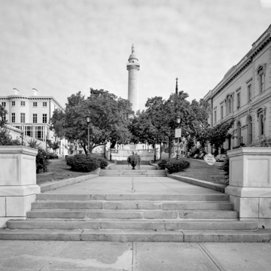](https://sah-archipedia.org/sites/default/files/pictures/full/MD-01-510-0002_001.jpg)
* [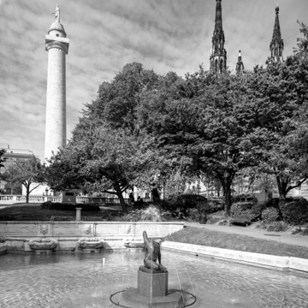](https://sah-archipedia.org/sites/default/files/pictures/full/MD-01-510-0002_002.jpg)
* [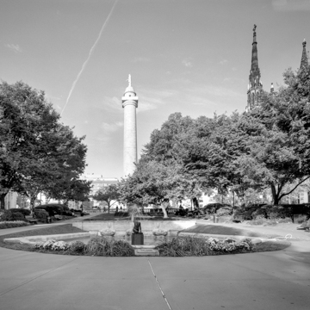](https://sah-archipedia.org/sites/default/files/pictures/full/MD-01-510-0002_003.jpg)
* [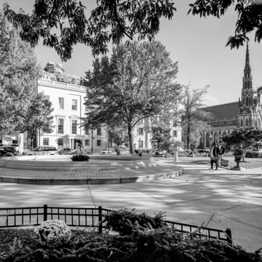](https://sah-archipedia.org/sites/default/files/pictures/full/MD-01-510-0002_004.jpg)
* [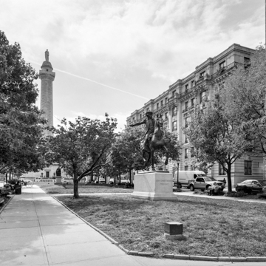](https://sah-archipedia.org/sites/default/files/pictures/full/MD-01-510-0002_005.jpg)
* [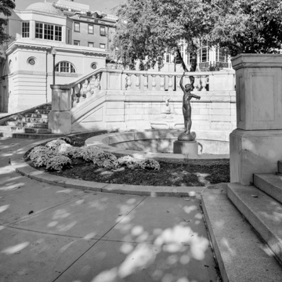](https://sah-archipedia.org/sites/default/files/pictures/full/MD-01-510-0002_006.jpg)
* [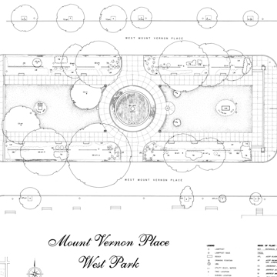](https://sah-archipedia.org/sites/default/files/pictures/full/MD-01-510-0002_007.jpg)
* [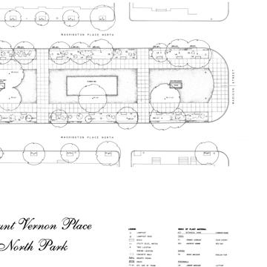](https://sah-archipedia.org/sites/default/files/pictures/full/MD-01-510-0002_008.jpg)
* [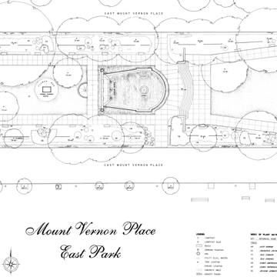](https://sah-archipedia.org/sites/default/files/pictures/full/MD-01-510-0002_009.jpg)
* [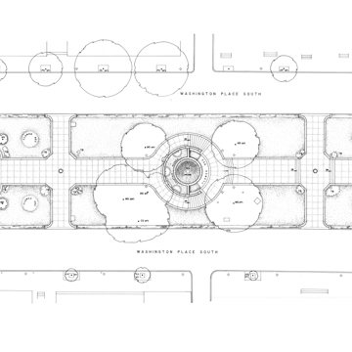](https://sah-archipedia.org/sites/default/files/pictures/full/MD-01-510-0002_010.jpg)
* [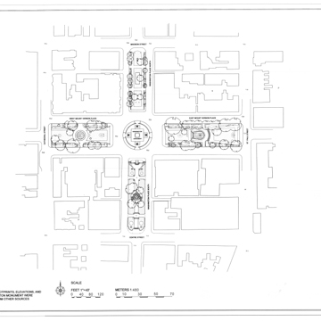](https://sah-archipedia.org/sites/default/files/pictures/full/MD-01-510-0002_011.jpg)
* 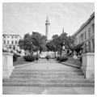
* 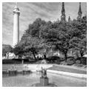
* 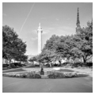
* 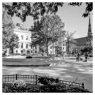
* 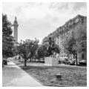
* 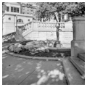
* 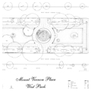
* 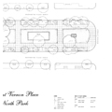
* 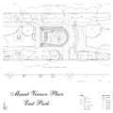
* 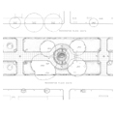
* 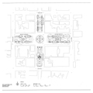

Mount Vernon Place is one of the best conceived and executed city planning projects of the nineteenth century. Initially begun as the site for Baltimore’s monument to George Washington, designed by Robert Mills and built between 1815 and 1829, Mount Vernon Place grew into a fashionable urban park and residential neighborhood and became the centerpiece of the city’s arts and culture district. Formerly the summit of “Belvedere,” the hillside estate of Colonel John Eager Howard was well outside the bounds of the colonial city. City managers optimistically selected it as the site of the Washington Monument, hoping to project Baltimore’s expansion northward. Charles Street, the main north-south axis, was extended to the monument to form a natural corridor for development. Once the monument was complete, city leaders called on Mills to expand his original plan beyond the area immediately around the monument. It was at this point that Mills laid out the current configuration of squares on north-south and east-west axes, named respectively “Washington Place” and “Mount Vernon Place” in honor of Washington and his Virginia home; over time the latter name came to describe the entire grouping. Some of the finest examples of period architecture in the city were eventually erected on the perimeter of Mount Vernon Place.

Mills’s original 1814 plan for the Washington Monument made little provision for the surrounding landscape, simply creating an encircling path around the base with four broad approaches. As the monument was nearing completion, Mills turned his attention to enhancing the site for desirable public and residential development. Formalized by legislation in 1831, Mills’s new plan called for the opening of a broad avenue, an extension of Charles Street, which splits from Madison to Centre streets, with the northbound traffic passing to one side of the square and the southbound to the other. East and West Mount Vernon Place each intersect this avenue at the monument to carry one-way traffic, although they only extend the length of the square, terminating at St. Paul Street to the east and Cathedral Street to the west. Mills suggested a 200-foot standard for the lots to the east and west of the monument to make them “of sufficient depth to answer all the conveniences of private dwellings.” Mills’s further interest in public benefit was made plain by his statement that “it is very desirable in this situation that some place for a promenade for the public should be provided.” In 1836 work began on grading, paving, and setting the curb stone for a broader landscape around the monument.

In 1850 a city ordinance initiated the long-sought improvement of the individual squares, consisting largely of the installation of iron fencing mounted on granite curbing and the planting of shade trees and ornamental shrubbery. By the time these improvements to Mount Vernon Place were completed, the city had expanded to meet it. Although the first house was built along it in 1829, the home of John Eager Howard’s son Charles, the park squares remained largely unimproved for several decades. It was not until the 1840s that a number of Baltimore’s wealthiest residents began to build their houses there. The first was William Tiffany, who erected his imposing Greek Revival house in 1842 (now the Mount Vernon Club, 8 West Mount Vernon Place). Next was an Italian Renaissance design for John H. Thomas by J. Rudolph Niernsee of the well-known Baltimore firm Niernsee and Neilson; built in 1849 it is now used by the Walters Art Gallery. The same firm also designed the Asbury House, c. 1855 (10 East Mount Vernon Place), and the Decatur Miller House, which features brownstone construction and iron balconies (700 Cathedral Street). In 1860, work began on the only speculative housing along Mount Vernon Place, “Brownstone Row,” which consists of six elegant matching town houses (22-32 East Mount Vernon Place). Other significant residences include the Garrett-Jacobs Mansion (7-11 West Mount Vernon Place), the home of the son of the president of the Baltimore and Ohio Railroad that was expanded in 1884 by Stanford White of McKim, Mead and White, and again by John Russell Pope in 1902 (now the Engineering Society of Baltimore); the home of A.S. Abell, a founder of the Baltimore Sun newspaper; and that of Theodore Marburg, a U.S. ambassador to Belgium. After World War I, a number of fashionable apartment buildings and hotels were built on or near the squares, adding to the imposing single-family residences that had earlier characterized the district. Most were executed in the Beaux-Arts tradition, whose stylistic variations were still fashionable at the time, including the Latrobe and Washington Apartments, and the Belvedere and Stafford hotels (since converted into apartments).

The first cultural institution to erect a structure at Mount Vernon Place was the Peabody Institute, whose Renaissance Revival design by English-born and trained architect Edmund G. Lind for a music hall and conservatory was realized in 1858–1862 (1 East Mount Vernon Place). The Peabody Library was added to the Music Hall and Conservatory in 1875–1878. The interior of the library contains five tiers of ornamental cast-iron book stacks that overlook an atrium that soars 61 feet to a latticed skylight; this exquisite space has been called the “Cathedral of Books.” In 1886, Enoch Pratt opened his Free Library along Mount Vernon Square, replaced by the current Beaux-Arts structure in 1933. It later formed the central branch of the city’s system of free libraries. Pratt’s house, at the corner of Park and Monument streets, is now part of the Maryland Historical Society complex. In 1909 came the construction of the original section of the Walters Art Gallery, designed by the New York architectural firm of Delano and Aldrich in the Italian Renaissance Revival style. The gallery had its roots in the Mount Vernon home of its benefactor, William Walters (later that of his son, Henry Walters). It opened for public viewing in the 1870s with 22,000 pieces including masterworks from all parts of the globe. The other monumental non-residential building is the stately High Victorian Gothic Mount Vernon Place Methodist Church, designed by Thomas Dixson and built of green serpentine stone in 1870–1872.

In 1875–1876 the city hired Frederick Law Olmsted’s Boston firm to redesign the north and south squares, while implementing similar designs in the east and west squares. In the fashion of the day, Mills’s rectilinear neoclassical design was remade to create a more curvilinear and picturesque landscape. The cast-iron fences that encircled the squares were removed, various pathways through the squares installed, and the grassy lawns were made over into sculpture gardens. Low decorative stone walls were added at the entrances, and trees were uniformly planted to frame the edges of the squares. The city placed statues of George Peabody, the benefactor of the Peabody Institute, and Severn Teackle Wallis, a prominent Baltimore attorney and political reformer of the late nineteenth century, in the east and north squares. Also in the north square are statues of Roger Brooke Taney, Chief Justice of the United States Supreme Court (1835 to 1864); and John Eager Howard, who donated the initial parcel of land that formed Mount Vernon Place. In the west square are several bronze animal sculptures produced by French sculptor Antoine-Louis Barye. These were donated by Henry Walters along with numerous other statues and bronzes including the four depictions of War, Peace, Order, and Force; and the statue of Military Courage by Paul Dubois. Fountains were also added to the east, west, and south squares.

The last major and enduring change to Mount Vernon Place came in 1917 when a new landscape plan was developed by one of America’s preeminent architectural firms, Carrère and Hastings. Shortly after the United States entered World War I, a statue was planned of the Marquis de Lafayette, who came to the aid of the American colonists during the Revolutionary War. The City of Baltimore brought in Thomas Hastings, at the time the surviving partner of the New York architectural firm, to design a setting for the Lafayette statue to honor fallen American and French World War I soldiers. The project quickly grew into a redesign of all the squares of Mount Vernon Place, which Hastings undertook over the course of several campaigns, beginning in 1917. Hastings’ design followed the classical vocabulary of the Beaux-Arts, while also reflecting the architectural and landscape treatments indicative of the City Beautiful movement, calling for symmetry, uniformity, and axial alignment. The equestrian statue of Lafayette was dedicated in 1924, the last addition to the site. Mount Vernon Place is among the finest extant urban landscapes designed by the Carrère and Hastings firm, and the finest example of nineteenth-century urban planning in Maryland. It remains today a vibrant residential community and cultural center.

REFERENCES

Lavoie, Catherine C. “Washington Memorial, Mount Vernon Place,” HABS No. MD-71, Historic American Buildings Survey, 2005. Prints and Photographs Division, Library of Congress, Washington, DC.

Miller, J. Jefferson, II. “Baltimore’s Washington Monument.” Master’s thesis, University of Delaware, 1962.

Mills Papers, 1820–1835, Maryland Historical Society, Manuscript Collection.

Morton, W. Brown, “Mount Vernon Place Historic District,” Baltimore City, Maryland. National Register of Historic Places Inventory-Nomination Form, 1971. National Park Service, U.S. Department of the Interior, Washington, DC.

WRITING CREDITS

**Author:**

Catherine C. Lavoie

**Coordinator:**

Catherine C. Lavoie

Lisa P. Davidson

**If SAH Archipedia has been useful to you, please consider supporting it.**







[**+−**](https://sah-archipedia.org/buildings/MD-01-510-0002)

[Leaflet](http://leafletjs.com/) | OSM Mapnik

FACTS

* LOCATION:

Baltimore Maryland

REGIONAL ESSAYS:

[Maryland](https://sah-archipedia.org/essays/MD-01)[Baltimore city](https://sah-archipedia.org/essays/MD-01-510)

ARCHITECT:

[Robert Mills](https://sah-archipedia.org/Architects/Robert-Mills)[Frederick Law Olmsted, Sr.](https://sah-archipedia.org/Architects/Frederick-Law-Olmsted-Sr)[Carrère and Hastings](https://sah-archipedia.org/Architects/Carr%C3%A8re-and-Hastings)

TYPES:

[squares (open spaces)](https://sah-archipedia.org/search/type/squares-open-spaces)[urban parks](https://sah-archipedia.org/search/type/urban-parks)[urban planning](https://sah-archipedia.org/search/type/urban-planning)[landscape gardens](https://sah-archipedia.org/search/type/landscape-gardens)[sculpture gardens](https://sah-archipedia.org/search/type/sculpture-gardens)

STYLES:

[Beaux-Arts (style)](https://sah-archipedia.org/search/style/Beaux-Arts-style)

MATERIALS:

[granite (rock)](https://sah-archipedia.org/search/material/granite-rock)[bronze (metal)](https://sah-archipedia.org/search/material/bronze-metal)[cast iron](https://sah-archipedia.org/search/material/cast-iron)[trees](https://sah-archipedia.org/search/material/trees)[grass (plant material)](https://sah-archipedia.org/search/material/grass-plant-material)[shrubs](https://sah-archipedia.org/search/material/shrubs)

SUBENTRIES:

[Peabody Institute](https://sah-archipedia.org/buildings/MD-01-510-0002-01), [Walters Art Museum](https://sah-archipedia.org/buildings/MD-01-510-0002-02), [18–28 East Mount Vernon Place](https://sah-archipedia.org/buildings/MD-01-510-0002-03)

TIMELINE

* 1829

Design and layout of squares

* 1875

Redesign of squares (picturesque)

* 1917

Redesign of squares (Beaux Arts)

WHAT'S NEARBY

[WASHINGTON MONUMENT (BALTIMORE)](https://sah-archipedia.org/buildings/MD-01-510-0001)

[PEABODY INSTITUTE](https://sah-archipedia.org/buildings/MD-01-510-0002-01)

[WALTERS ART MUSEUM](https://sah-archipedia.org/buildings/MD-01-510-0002-02)

[18–28 EAST MOUNT VERNON PLACE](https://sah-archipedia.org/buildings/MD-01-510-0002-03)

[BASILICA OF THE NATIONAL SHRINE OF THE ASSUMPTION OF THE BLESSED VIRGIN MARY](https://sah-archipedia.org/buildings/MD-01-510-0086)

CITATION

Catherine C. Lavoie, "[Mount Vernon Place](https://sah-archipedia.org/buildings/MD-01-510-0002)", [[Baltimore](https://sah-archipedia.org/Cities/Baltimore), [Maryland](https://sah-archipedia.org/States/Maryland)], SAH Archipedia, eds. Gabrielle Esperdy and Karen Kingsley, Charlottesville: UVaP, 2012—, [http://sah-archipedia.org/buildings/MD-01-510-0002](https://sah-archipedia.org/buildings/MD-01-510-0002).

Last accessed: May 13, 2021.

[Permissions and Terms of Use](https://sah-archipedia.org/buildings/content/Copyright-and-Terms-of-Use)

*1829–1836, Robert Mills; 1875–1876 redesign, Frederick Law Olmsted; 1917–1924 redesign, Carrère and Hastings. Along Charles St. and bounded by St. Paul, Cathedral, W. Madison, and W. Centre sts.*

* [](https://sah-archipedia.org/sites/default/files/pictures/full/MD-01-510-0002_001.jpg)
* [](https://sah-archipedia.org/sites/default/files/pictures/full/MD-01-510-0002_002.jpg)
* [](https://sah-archipedia.org/sites/default/files/pictures/full/MD-01-510-0002_003.jpg)
* [](https://sah-archipedia.org/sites/default/files/pictures/full/MD-01-510-0002_004.jpg)
* [](https://sah-archipedia.org/sites/default/files/pictures/full/MD-01-510-0002_005.jpg)
* [](https://sah-archipedia.org/sites/default/files/pictures/full/MD-01-510-0002_006.jpg)
* [](https://sah-archipedia.org/sites/default/files/pictures/full/MD-01-510-0002_007.jpg)
* [](https://sah-archipedia.org/sites/default/files/pictures/full/MD-01-510-0002_008.jpg)
* [](https://sah-archipedia.org/sites/default/files/pictures/full/MD-01-510-0002_009.jpg)
* [](https://sah-archipedia.org/sites/default/files/pictures/full/MD-01-510-0002_010.jpg)
* [](https://sah-archipedia.org/sites/default/files/pictures/full/MD-01-510-0002_011.jpg)
* 
* 
* 
* 
* 
* 
* 
* 
* 
* 
* 

Mount Vernon Place is one of the best conceived and executed city planning projects of the nineteenth century. Initially begun as the site for Baltimore’s monument to George Washington, designed by Robert Mills and built between 1815 and 1829, Mount Vernon Place grew into a fashionable urban park and residential neighborhood and became the centerpiece of the city’s arts and culture district. Formerly the summit of “Belvedere,” the hillside estate of Colonel John Eager Howard was well outside the bounds of the colonial city. City managers optimistically selected it as the site of the Washington Monument, hoping to project Baltimore’s expansion northward. Charles Street, the main north-south axis, was extended to the monument to form a natural corridor for development. Once the monument was complete, city leaders called on Mills to expand his original plan beyond the area immediately around the monument. It was at this point that Mills laid out the current configuration of squares on north-south and east-west axes, named respectively “Washington Place” and “Mount Vernon Place” in honor of Washington and his Virginia home; over time the latter name came to describe the entire grouping. Some of the finest examples of period architecture in the city were eventually erected on the perimeter of Mount Vernon Place.

Mills’s original 1814 plan for the Washington Monument made little provision for the surrounding landscape, simply creating an encircling path around the base with four broad approaches. As the monument was nearing completion, Mills turned his attention to enhancing the site for desirable public and residential development. Formalized by legislation in 1831, Mills’s new plan called for the opening of a broad avenue, an extension of Charles Street, which splits from Madison to Centre streets, with the northbound traffic passing to one side of the square and the southbound to the other. East and West Mount Vernon Place each intersect this avenue at the monument to carry one-way traffic, although they only extend the length of the square, terminating at St. Paul Street to the east and Cathedral Street to the west. Mills suggested a 200-foot standard for the lots to the east and west of the monument to make them “of sufficient depth to answer all the conveniences of private dwellings.” Mills’s further interest in public benefit was made plain by his statement that “it is very desirable in this situation that some place for a promenade for the public should be provided.” In 1836 work began on grading, paving, and setting the curb stone for a broader landscape around the monument.

In 1850 a city ordinance initiated the long-sought improvement of the individual squares, consisting largely of the installation of iron fencing mounted on granite curbing and the planting of shade trees and ornamental shrubbery. By the time these improvements to Mount Vernon Place were completed, the city had expanded to meet it. Although the first house was built along it in 1829, the home of John Eager Howard’s son Charles, the park squares remained largely unimproved for several decades. It was not until the 1840s that a number of Baltimore’s wealthiest residents began to build their houses there. The first was William Tiffany, who erected his imposing Greek Revival house in 1842 (now the Mount Vernon Club, 8 West Mount Vernon Place). Next was an Italian Renaissance design for John H. Thomas by J. Rudolph Niernsee of the well-known Baltimore firm Niernsee and Neilson; built in 1849 it is now used by the Walters Art Gallery. The same firm also designed the Asbury House, c. 1855 (10 East Mount Vernon Place), and the Decatur Miller House, which features brownstone construction and iron balconies (700 Cathedral Street). In 1860, work began on the only speculative housing along Mount Vernon Place, “Brownstone Row,” which consists of six elegant matching town houses (22-32 East Mount Vernon Place). Other significant residences include the Garrett-Jacobs Mansion (7-11 West Mount Vernon Place), the home of the son of the president of the Baltimore and Ohio Railroad that was expanded in 1884 by Stanford White of McKim, Mead and White, and again by John Russell Pope in 1902 (now the Engineering Society of Baltimore); the home of A.S. Abell, a founder of the Baltimore Sun newspaper; and that of Theodore Marburg, a U.S. ambassador to Belgium. After World War I, a number of fashionable apartment buildings and hotels were built on or near the squares, adding to the imposing single-family residences that had earlier characterized the district. Most were executed in the Beaux-Arts tradition, whose stylistic variations were still fashionable at the time, including the Latrobe and Washington Apartments, and the Belvedere and Stafford hotels (since converted into apartments).

The first cultural institution to erect a structure at Mount Vernon Place was the Peabody Institute, whose Renaissance Revival design by English-born and trained architect Edmund G. Lind for a music hall and conservatory was realized in 1858–1862 (1 East Mount Vernon Place). The Peabody Library was added to the Music Hall and Conservatory in 1875–1878. The interior of the library contains five tiers of ornamental cast-iron book stacks that overlook an atrium that soars 61 feet to a latticed skylight; this exquisite space has been called the “Cathedral of Books.” In 1886, Enoch Pratt opened his Free Library along Mount Vernon Square, replaced by the current Beaux-Arts structure in 1933. It later formed the central branch of the city’s system of free libraries. Pratt’s house, at the corner of Park and Monument streets, is now part of the Maryland Historical Society complex. In 1909 came the construction of the original section of the Walters Art Gallery, designed by the New York architectural firm of Delano and Aldrich in the Italian Renaissance Revival style. The gallery had its roots in the Mount Vernon home of its benefactor, William Walters (later that of his son, Henry Walters). It opened for public viewing in the 1870s with 22,000 pieces including masterworks from all parts of the globe. The other monumental non-residential building is the stately High Victorian Gothic Mount Vernon Place Methodist Church, designed by Thomas Dixson and built of green serpentine stone in 1870–1872.

In 1875–1876 the city hired Frederick Law Olmsted’s Boston firm to redesign the north and south squares, while implementing similar designs in the east and west squares. In the fashion of the day, Mills’s rectilinear neoclassical design was remade to create a more curvilinear and picturesque landscape. The cast-iron fences that encircled the squares were removed, various pathways through the squares installed, and the grassy lawns were made over into sculpture gardens. Low decorative stone walls were added at the entrances, and trees were uniformly planted to frame the edges of the squares. The city placed statues of George Peabody, the benefactor of the Peabody Institute, and Severn Teackle Wallis, a prominent Baltimore attorney and political reformer of the late nineteenth century, in the east and north squares. Also in the north square are statues of Roger Brooke Taney, Chief Justice of the United States Supreme Court (1835 to 1864); and John Eager Howard, who donated the initial parcel of land that formed Mount Vernon Place. In the west square are several bronze animal sculptures produced by French sculptor Antoine-Louis Barye. These were donated by Henry Walters along with numerous other statues and bronzes including the four depictions of War, Peace, Order, and Force; and the statue of Military Courage by Paul Dubois. Fountains were also added to the east, west, and south squares.

The last major and enduring change to Mount Vernon Place came in 1917 when a new landscape plan was developed by one of America’s preeminent architectural firms, Carrère and Hastings. Shortly after the United States entered World War I, a statue was planned of the Marquis de Lafayette, who came to the aid of the American colonists during the Revolutionary War. The City of Baltimore brought in Thomas Hastings, at the time the surviving partner of the New York architectural firm, to design a setting for the Lafayette statue to honor fallen American and French World War I soldiers. The project quickly grew into a redesign of all the squares of Mount Vernon Place, which Hastings undertook over the course of several campaigns, beginning in 1917. Hastings’ design followed the classical vocabulary of the Beaux-Arts, while also reflecting the architectural and landscape treatments indicative of the City Beautiful movement, calling for symmetry, uniformity, and axial alignment. The equestrian statue of Lafayette was dedicated in 1924, the last addition to the site. Mount Vernon Place is among the finest extant urban landscapes designed by the Carrère and Hastings firm, and the finest example of nineteenth-century urban planning in Maryland. It remains today a vibrant residential community and cultural center.

REFERENCES

Lavoie, Catherine C. “Washington Memorial, Mount Vernon Place,” HABS No. MD-71, Historic American Buildings Survey, 2005. Prints and Photographs Division, Library of Congress, Washington, DC.

Miller, J. Jefferson, II. “Baltimore’s Washington Monument.” Master’s thesis, University of Delaware, 1962.

Mills Papers, 1820–1835, Maryland Historical Society, Manuscript Collection.

Morton, W. Brown, “Mount Vernon Place Historic District,” Baltimore City, Maryland. National Register of Historic Places Inventory-Nomination Form, 1971. National Park Service, U.S. Department of the Interior, Washington, DC.

WRITING CREDITS

**Author:**

Catherine C. Lavoie

**Coordinator:**

Catherine C. Lavoie

Lisa P. Davidson

**If SAH Archipedia has been useful to you, please consider supporting it.**